Post | Copy | Image
Post 1:  Coming  Soon | Introducing ParentPay, your cashless school payments system.​  ​  Join 4 million parents who are already using ParentPay to make speedy, secure school payments every day.​  ​  #EdTech #CashlessPayments | 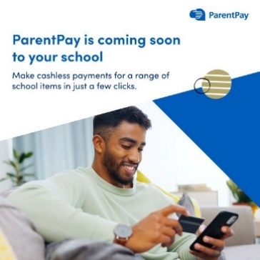
Post 2: What to Expect | With ParentPay you can rest easy, as your school money is in safe hands.​  ​  We will shortly be offering flexible payment options for uniform, clubs, trips, school meals, and much more through ParentPay.​  ​  #EdTech #CashlessPayments | 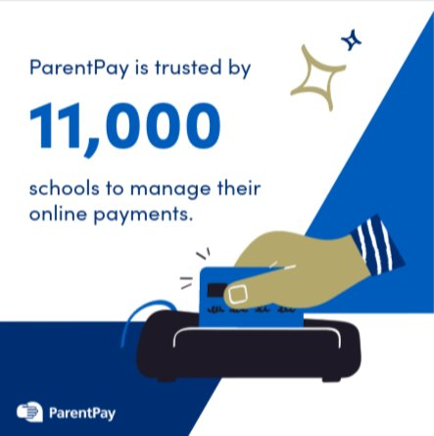
Post 3: Home to All Your School Payments  (Two options for creative) | Get ready to go digital! Pay for school dinners, trips, and clubs effortlessly and securely with ParentPay.​  ​  Start your cashless journey today by activating your ParentPay account. | 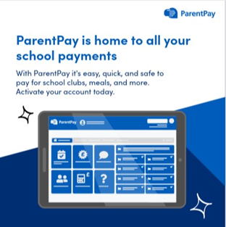  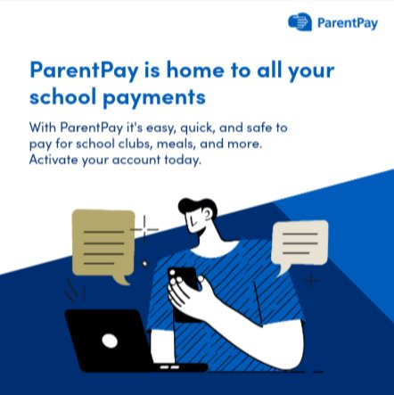
Post 4: How to Get Started | Don’t forget to set up your ParentPay account.​  All you need is your activation letter and access to your email address. ​  Simply head to the ParentPay website to get started 👉 https://app.parentpay.com/public/client/security/v2/#/login | 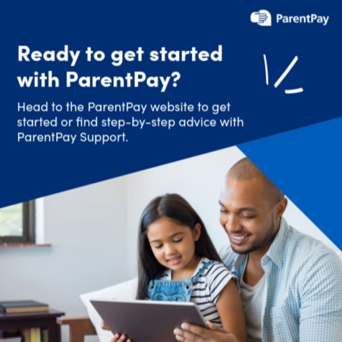
Post 5: Setting Alerts | Say goodbye to cash stuffed envelopes and school letters going missing in book bags…​  ​  Sign up for ParentPay alerts, so you and your child don’t miss out on school trips and events. | 